http://i.dailymail.co.uk/i/pix/2015/08/13/16/2B5527C800000578-3196583-Most_translators_interpreted_two_emoji_showing_a_sick_face_and_a-a-63_1439481588110.jpghttps://keetonsonline.files.wordpress.com/2015/05/0753.png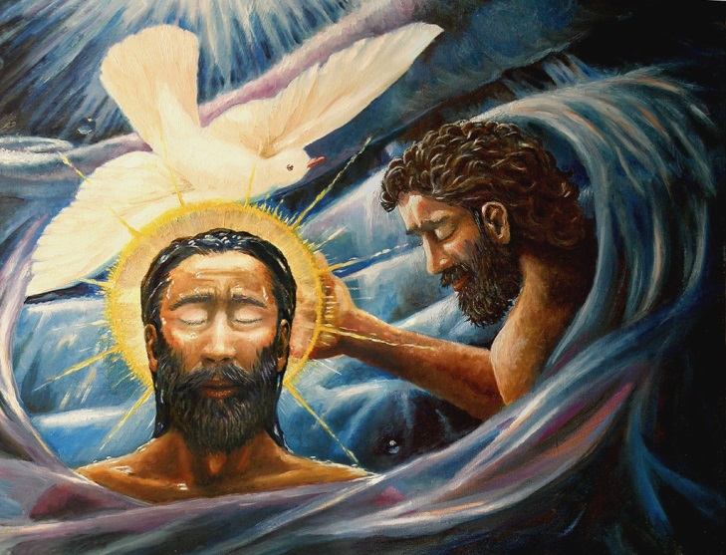

**Many Christians think this is the good title for Jesus because it is not vague as it clearly states who Jesus is.**

**It shows the closeness of Jesus to God.**

**It reminds Christians of Jesus’ power to heal and save; it shows that Jesus has God’s power.**

**‘Son of God’ was commonly used to describe Jesus after his death and Resurrection, and is used widely in the Church today.**

**Jesus never used this title to describe himself.**

**In Jewish Scriptures the king of Israel was called God’s son.**

**This title highlights that Jesus is divine (like God).**

**Who do you think said these quotes? What do they indicate about this individual’s opinion of Jesus?**

***“This is my own dear Son- listen to Him.”***

**A**

***“You are my own dear Son. I am pleased with you.”***

***Station A – ‘Son of God’***

**S**





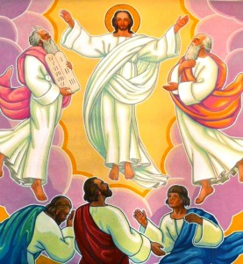

**‘Son of God’ was used in two stories:**

**Jesus’ baptism**

**The story of the Transfiguration.**

**You will learn about these stories as we go through Mark’s Gospel.**





**The Jews believed that a Messiah would come to save them. Some Jews expected the Messiah to be a prophet (God’s messenger), like Moses.**

**Others expected a military Messiah and a descendant of King David (whom Jews regarded as being the greatest King of Israel), who would make Israel a free kingdom by driving out the Romans as they were occupying the Jewish land.**

**The Greek word *Christ,* and the Hebrew word *Messiah,* both mean ‘Anointed One’.**

**The Jewish people believed that God would send them a great leader. They called him “The Anointed One” because they used to anoint their leaders with oil as a sign of God’s favour; they had been chosen to carry out a special task.**

**Can you think of any events today where Christians use oil to anoint?**

**How can these Christian events link to being ‘specially chosen’?**

http://i.dailymail.co.uk/i/pix/2015/08/13/16/2B5527C800000578-3196583-Most_translators_interpreted_two_emoji_showing_a_sick_face_and_a-a-63_1439481588110.jpg

**H**

**Jesus never referred to himself as the ‘Messiah’ (or ‘Christ’) because people who called him that would expect him to act like an earthly king or a powerful military leader.**

**Jesus seems to identify himself with Isaiah’s prophecy of a ‘Suffering Servant’.**

***Station B – ‘Christ’ / ‘Messiah’***



***“You are the Messiah”***

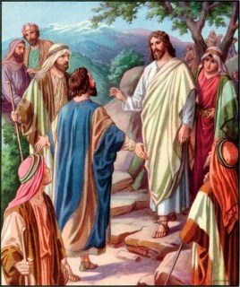

***“Who do you say I am?”***



**After his resurrection, it became such a popular title for him that now Christians use the word ‘Christ’ almost as if it was his last name.**

**Christians believe this title suits Jesus’ role as he was chosen by God to carry out a special task of bringing Christianity.**

**The title ‘Messiah’ is used in the story of Peter’s Declaration in Caesarea.**

**You will learn about this story as we go through Mark’s Gospel.**

http://i.dailymail.co.uk/i/pix/2015/08/13/16/2B5527C800000578-3196583-Most_translators_interpreted_two_emoji_showing_a_sick_face_and_a-a-63_1439481588110.jpg

**M**



**Jesus’ family tree can be traced back to David, thus making Jesus a descendant of King David.**

**When believers call Jesus ‘Son of David’ they are showing that they believe him to be the Messiah.**

**However, ‘Son of David’ is not a common title for Christians to use today as many people do not understand it.**

**King David was regarded as the greatest king of Israel. Most Jews expected that their future Messiah would be a descendant of King David, chosen by God to rule as king.**

https://pbs.twimg.com/profile_images/2317031397/1C0D9A90-6FDF-4025-8826-C5129C1F2E18_400x400

**Look at the image of Jesus entering Jerusalem on a donkey. How does this quote link to Jesus being referred to as ‘Son of David’?**

***Station C – ‘Son of David’***

http://i.dailymail.co.uk/i/pix/2015/08/13/16/2B5527C800000578-3196583-Most_translators_interpreted_two_emoji_showing_a_sick_face_and_a-a-63_1439481588110.jpg

**Jesus never referred to himself as ‘Son of David’.**



***“God bless the coming kingdom of King David.”***

***“Jesus! Son of David! Have mercy on me!”***

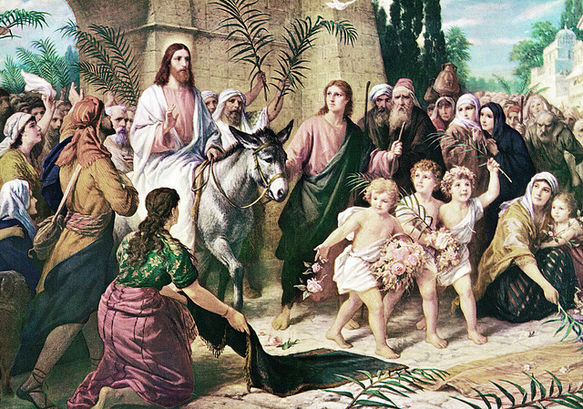

**S**

***“Jesus! Son of David! Have mercy on me!”***

http://i.dailymail.co.uk/i/pix/2015/08/13/16/2B5527C800000578-3196583-Most_translators_interpreted_two_emoji_showing_a_sick_face_and_a-a-63_1439481588110.jpg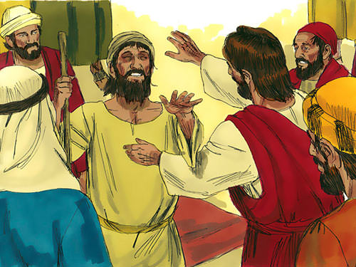

**‘Son of David’ was used in two stories:**

**Jesus’ Entry into Jerusalem**

**The Healing of Blind Bartimaeus**

**You will learn about these stories as we go through Mark’s Gospel.**

***“Your faith has made you well.”***



**‘Son of Man’ has two meanings:**

**1. It was used by the prophet Ezekiel in reference to being an ordinary person.**

**2. It was also used by the prophet Daniel to describe a figure with authority from God.**

**The ‘Son of Man’ was God’s representative and acted with God’s authority.**

**Many Christians believe that ‘Son of Man’ is a good title for Jesus as it shows he has God’s authority and it emphasises his humanity, making him more accessible to people.**

**It was the title that Jesus preferred and used it frequently. It has no political links so it was a safe title for Jesus to use.**

**On the other hand, it is a Jewish title and perhaps has no meaning for Christians today.**

http://i.dailymail.co.uk/i/pix/2015/08/13/16/2B5527C800000578-3196583-Most_translators_interpreted_two_emoji_showing_a_sick_face_and_a-a-63_1439481588110.jpg

***Station D – ‘Son of Man’***

**E**

**Jesus often referred to himself as the ‘Son of Man’ when he talked about his ministry on earth, his death, and his Ascension into heaven.**



**‘Son of Man’ is used fourteen times in Mark’s Gospel.**

**It is mentioned in the following stories:**

**Peter’s Declaration, The Transfiguration, The Request of James and John, The Paralysed Man, The Last Supper, The Garden of Gethsemane and The Trial before the Sanhedrin.**

**You will learn about each of these stories as we go through Mark’s Gospel.**

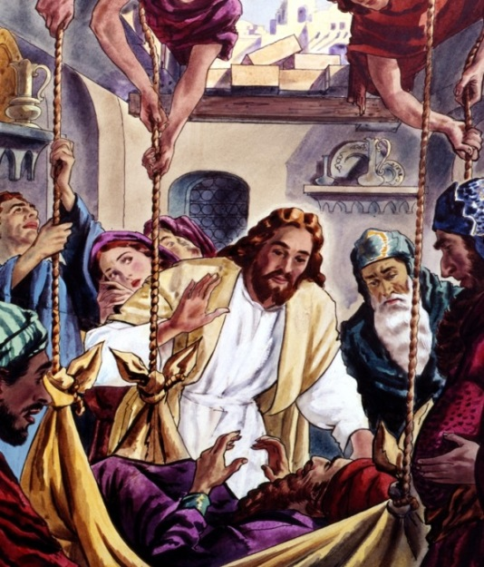

**“My son, your sins are forgiven…”**

**“…I will prove to you that the Son of Man has the authority to forgive sins.”**

https://pbs.twimg.com/profile_images/2317031397/1C0D9A90-6FDF-4025-8826-C5129C1F2E18_400x400

**From the stories listed in the box on the left, which one do you think this image is linked to? Jesus tells the man that his “sins are forgiven”. How does this relate to ‘Son of Man’?**

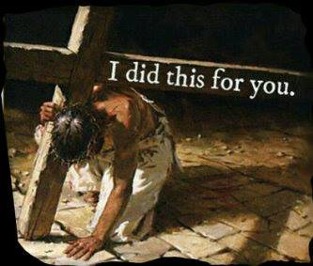

**Old Testament prophecy states that God would send a deliverer.**

**The name ‘Jesus’ means ‘God saves’.**

**Saviour is linked to the word- Salvation- which means ‘saved from sin’.**

**Christians believe that Jesus offers Salvation to humankind by saving them from sin through his death and Resurrection.**

**Christians believe that Jesus saves people from their sins.**

**Saviour is a title that is easy to understand as it simply means the one who saves. Jesus saved people on a daily basis. It is a true reflection of Jesus.**

**However, the title presents only one aspect of the life and ministry of Jesus.**



***Station E – ‘Saviour’***

**Look at the three images and discuss how they show Jesus as a ‘Saviour’.**

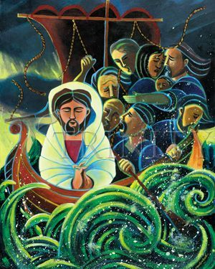

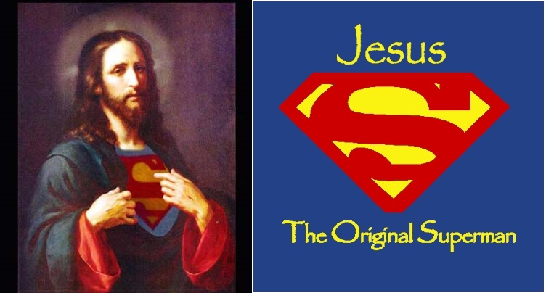

**Jesus never referred to himself as ‘Saviour’.**

**Jesus’ qualities of being a saviour can be seen in the following stories:**

**The Calming of the Storm**

**Jesus’ Death**

**You will learn about these stories in more detail as we go through Mark’s Gospel.**

**I**